**Test Summary**

PPDM Privacy Policy Data Metrics project is all about showing cookies details for particular website.

There are two aspects of it frontend and backend in Oddo.

We perform functional testing for all flows to store website cookies data and map it to show in frontend.

All test cases, test execution, defects are stored in JIRA and tracked in Microsoft Planner.

**Backend Data**

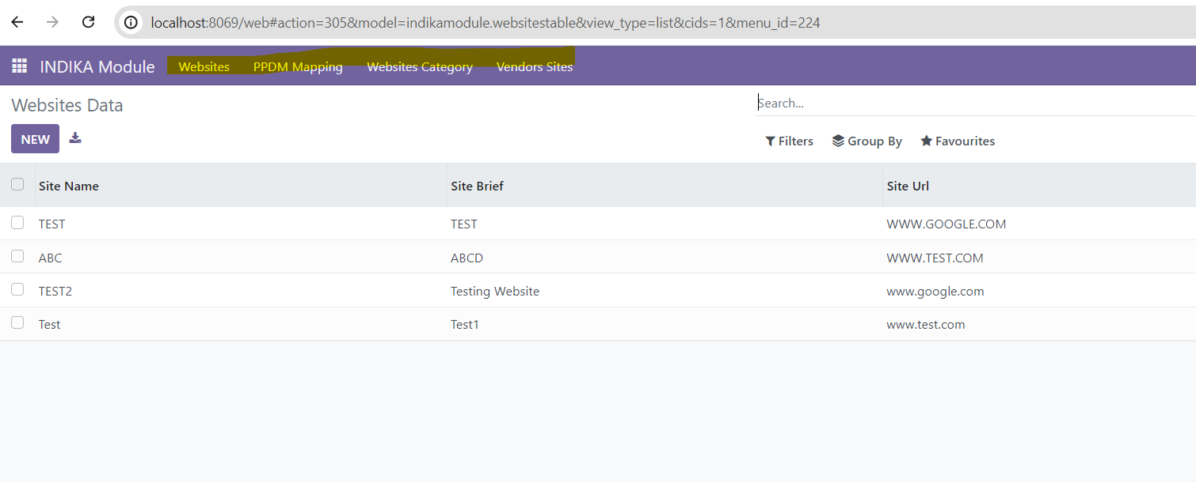

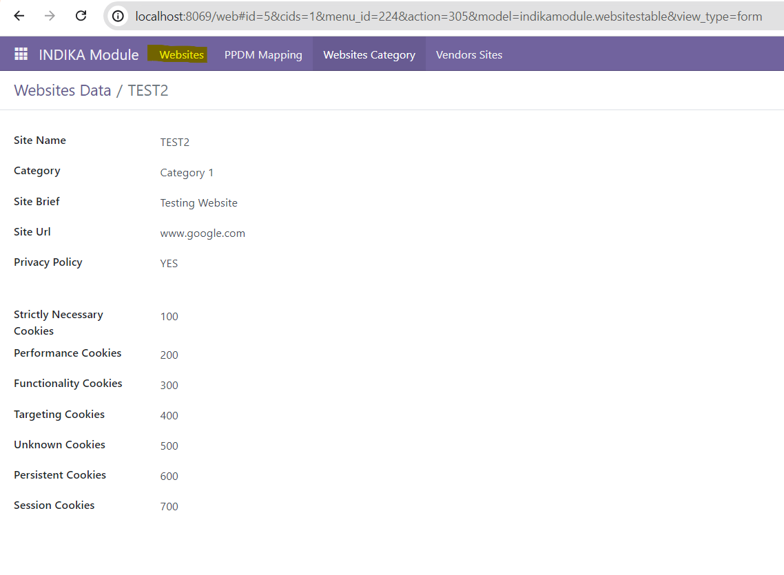

**Frontend**

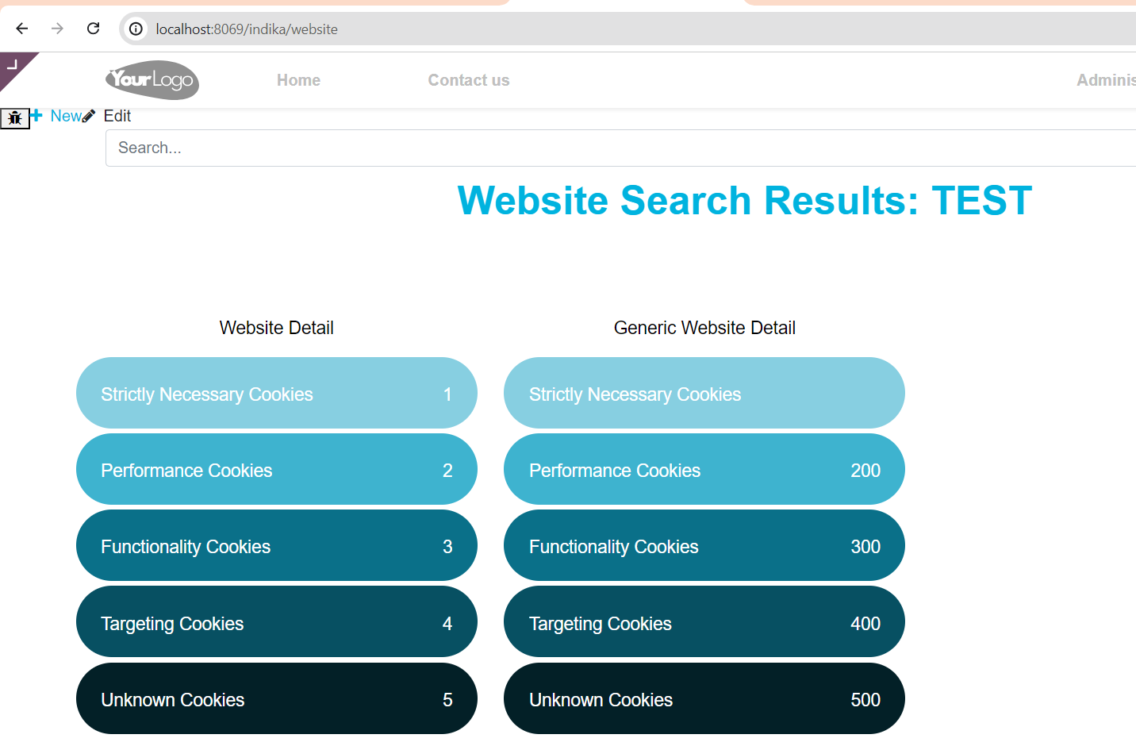

**Postgres DB Testing**

